## PRD - Product Requirements Document- Mix-It

Yogev Hassid & Ron Azu

### 1. Purpose of the Product

**The purpose of the product** is mainly for challenge and in addition - developing the capabilities of color combinations

**The system solves a number of problems such as:** a problem of parents trying to expand their children's skills without success and looking for original fun and unforced ways to do it, children with inability to notice colors and even a financial problem for parents who will not have to buy coloring books and paints

An Eco-Friendly and cleaner environment, that is - more digital experience, without throwing papers and colors, without the need to clean after painting

**The product is for ages 5-99 +** , and the target audience is: parents who want to teach their children color combinations but want to do so in a more attractive way, or anyone who loves coloring and wants to learn color combinations and acquire new coloring skills

**The product is important** because knowledge of color combinations is a tool needed by the adolescent for the rest of his life, especially for artists

In addition the product is important because there are lots of parents who spend unnecessary money on coloring books, paints and papers and can save this by using our product

### 2. Break the Purpose Down Into Features

**a. Between 5-15 stages in the game:**

In order to provide the player an addictive experience, we will create a sufficient number of stages with different levels of difficulty

**b. Results table:**

### Each player will have a scoreboard with access to all the results of the stages he went through and be able to see his drawings

**c. Demo Game:**

## The player will be able to enter a demo game where he will practice how the game and drawing works

**d. Performance improvement by Color Matching Algorithm:**

At the end of each stage, in order to show the player a review of his painting in the best and most accurate way, we will use an algorithm that checks the match between the object in the landscape and the player's drawing

**e. Hint:**

At each stage we allow the player to use a single hint that gives him the colors of the combination that should be painted in a certain area in the drawing.

In addition - the use of the hint will decrease the player score

### 3. Goals For the Release Criteria

#### Functionality:

a. The system will not exceed 1 GB of storage

b. The system will store all the player data at each stage in a database and will allow access to this data at a constant runtime

#### Usability:

a. All screens will be clear to read and operate, that is - the screen buttons and the text composed of them will be clear, icons such as audio, settings, etc. will be on the sides of the screen and the background of each screen will be colorful and attractive

#### Reliability:

a. Every 3 minutes the system will save the player's data including: stage, current drawing, time remaining and score, thus every time the computer shut down or the player exits the game - the player will return to where he left off

#### Performance:

a. The matching check that will determine the drawing score will be performed in between 3 and 6 seconds

b. Each stage of the game will be loaded with a speed of up to 3 seconds

#### Supportability:

a. It will be possible to use the system online on the Internet with Web-GL

b. The system will be available for download to the player's computer

**4. Determine the Timeline**

**We estimate that we will complete the construction of the system** on all its parts by 6.7.21, when all parts of the project are:

**1. System design** - building the screens, objects and user interface

**2. System programming** - writing the matching algorithm, writing all stages of the game, moving objects and system functionality

**3. System tests** - We will perform a playtests that will include a comprehensive examination of each stage, checking the game levels with different users, identifying bugs and closing final unclosed stuff

**Use Cases:**

**Once the user enters the game**, the game menu will open with a number of buttons - a new game, a demo game, a scoreboard and exit.

At the user's first entry into the game, there will be an arrow pointing towards the **demo game** button - where he will be able to learn how to operate the game.

In the **demo game screen** - a simple step will be displayed with a view, an object that the user have to paint, a coloring page under which is a surface with paint cans, brushes and an eraser.

There will be sound and a main menu icons on the sides of the screen, and in addition - there will be objects of a clock that will show the time that has elapsed since the beginning of the level.

In addition - throughout the demo game there will be arrows next to the brushes and paint cans that will teach the player the operation of the game.

In the next entries of the user, after learning the operation of the game, he will click on a **new game** and start the first level.

The **game screen** will be similar to the demo game screen except for the arrows that help with the operation, the landscape, the changing color cans, the difficulty level and the appropriate background music.

In the **results table screen** - the user will be able to choose between 2 tables: a **personal table** in which the highest data accumulated in each game include: score, level and time, and a **general table** where the higher data that all users have accumulated include: score, level, time and player name.

**Screenshots:**

**Menu screen**

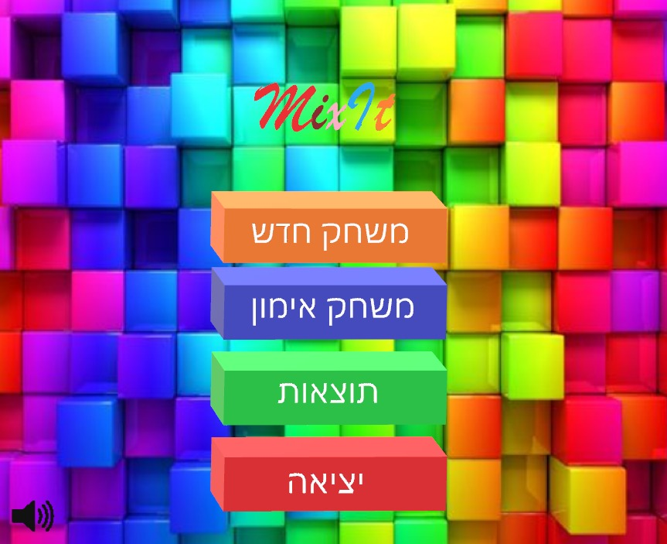

**Demo game screen**

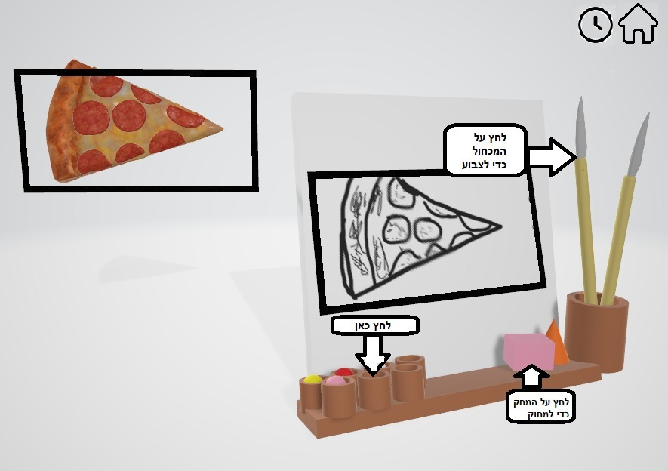

**Game screen**

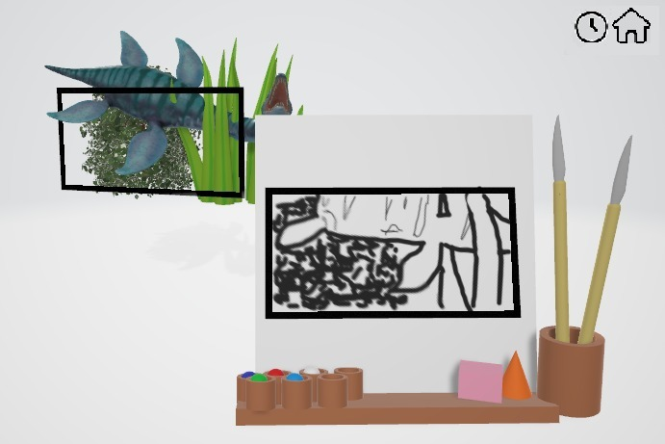

**Result table screen**

